# Test Report – IAP Vs IMP for Spinal Stability.

**Date** : 19st July, 2019.

**Name** : Siril Teja Dukkipati

**Test** : Spinal stability dependency on IAP and IMP

**No of data points collected** : 16 in total.

The definition of Spinal Stability in the “White Paper on Sagittal Plane Alignment” by Scoliosis Research Society has a range of accepted range of values for the plumb line error i.e. +- 2cms or +-0.787 in.

This gives some amount of flexibility for IAP and IMP in a stable spine.

In this experiment, different values of IAP and IMP are maintained and Spinal stability is observed. All the data points are plotted on the graph.

The unstable and stable data points are marked Orange and Blue respectively.

We can clearly see a region of pressure points where the spine is unstable.



The data from Brittany’s experiment is also plotted for comparison.

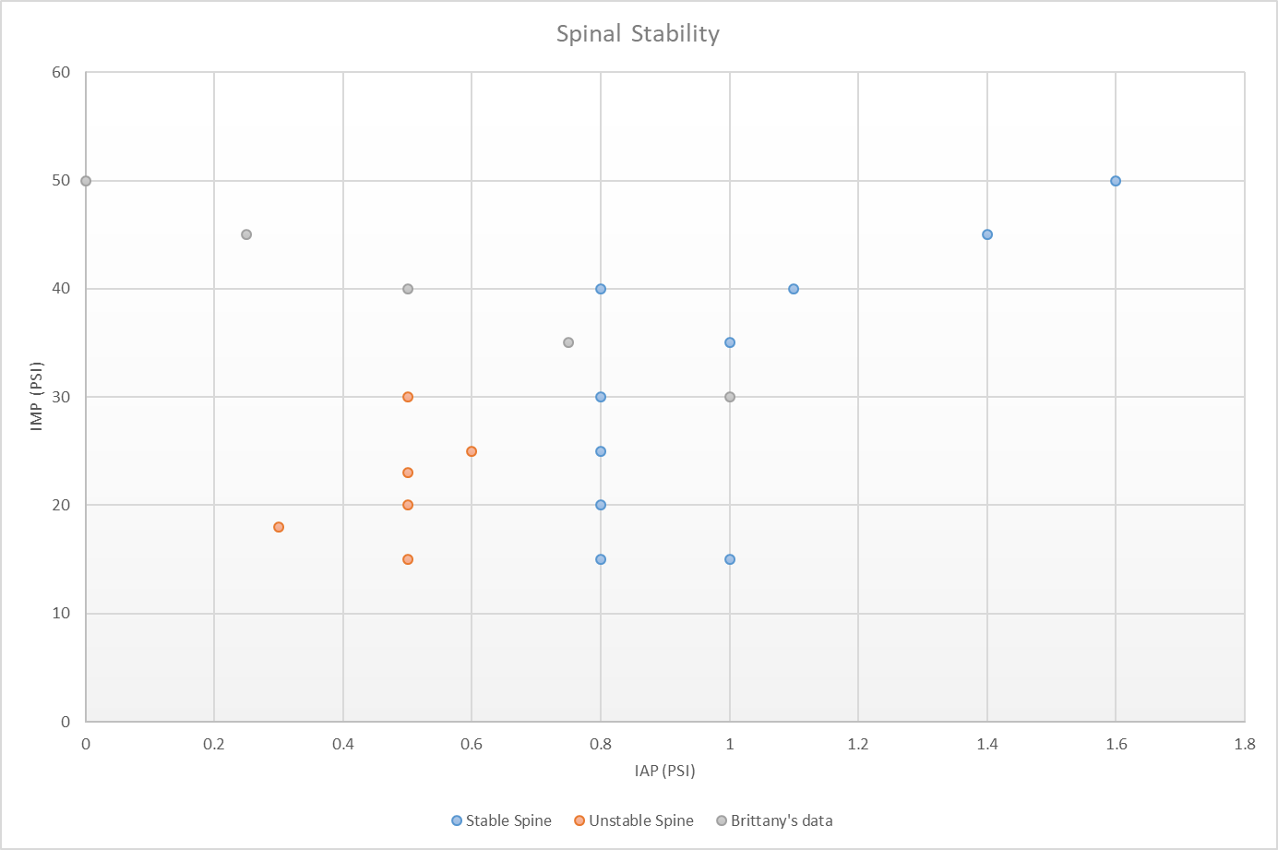

**Conclusions** :

1. It can be seen that Spinal stability depends on the Intra-Muscular pressure and the Intra-Abdominal pressure.
2. There exists a particular region in the graph where the spine is not stable.
3. The is done on a benchtop model. So the pressure values differ from the in-vivo values.